**DEMETRIA, CHRISTIAN JAY A.**

**IPT2 CASE STUDY DOCUMENTATION**

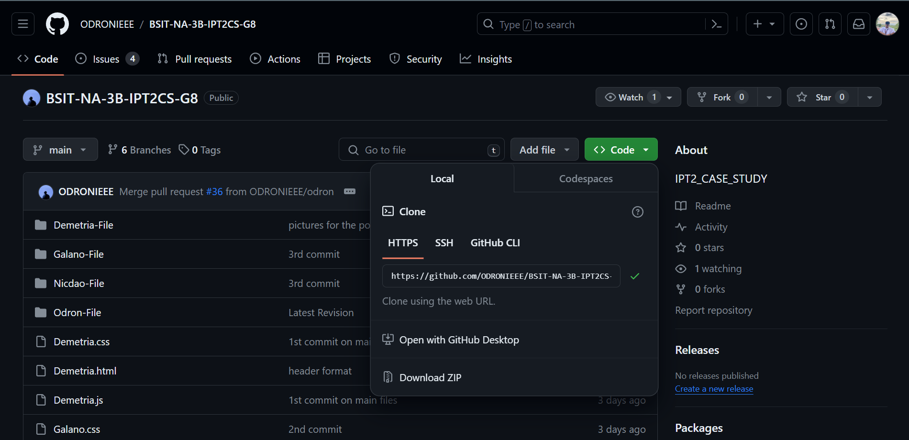

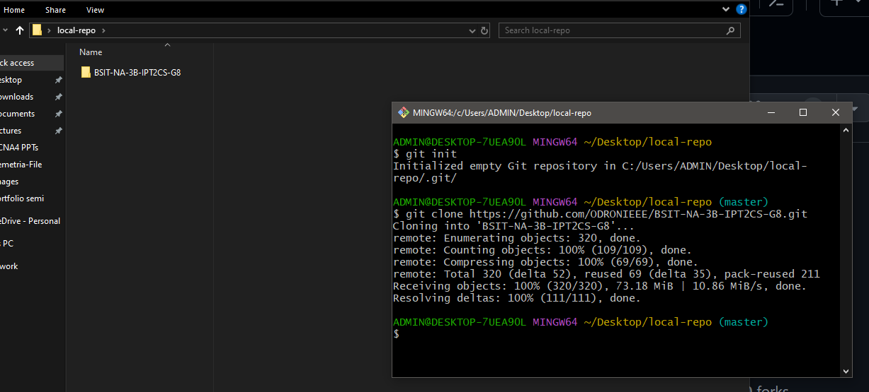

Initialize the local repository and cloning our repository in Git Hub named **BSIT-NA-3B-IPT2CS-G8**.

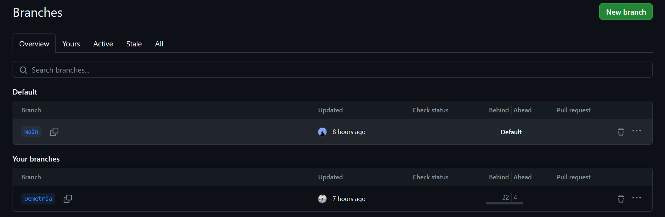

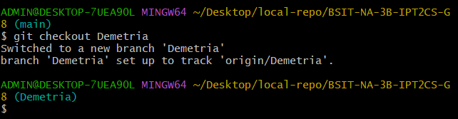

Branch Created. Take note that in this part, I switch back to my branch because I already created my branch.

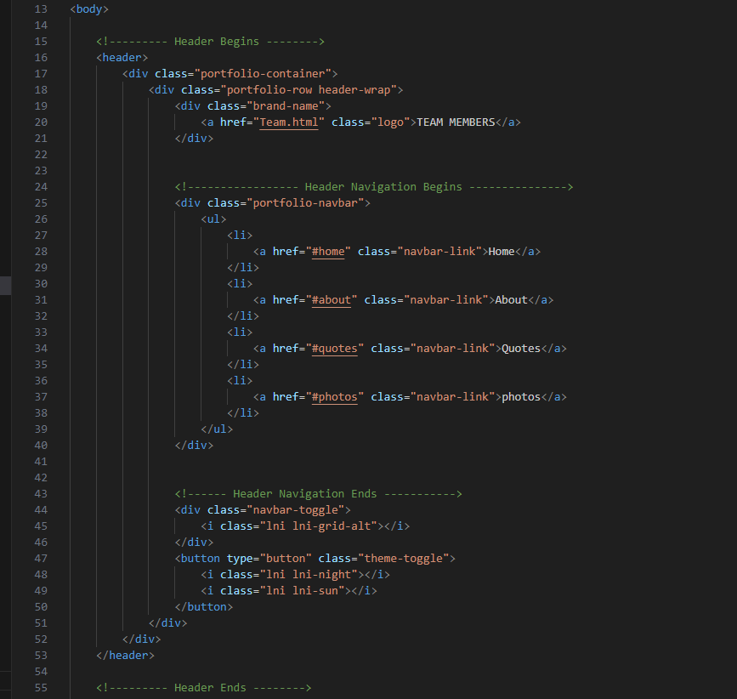 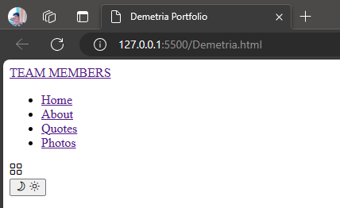

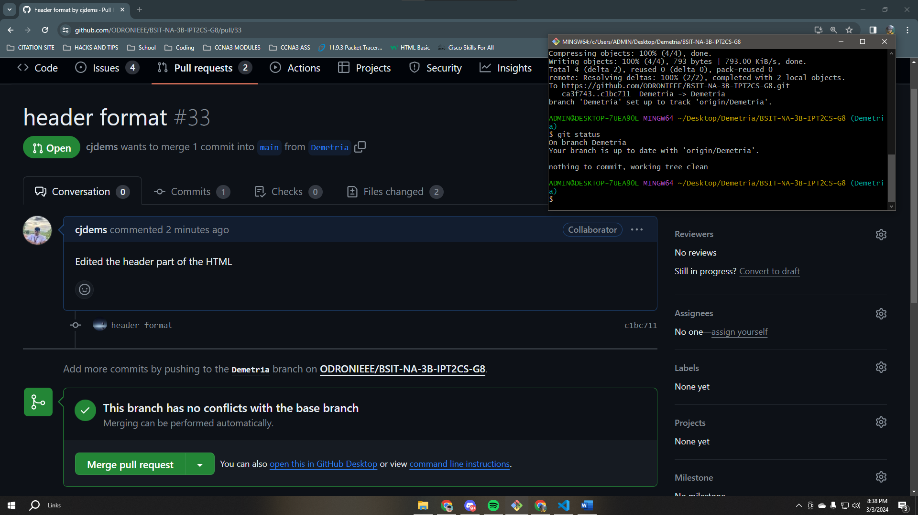

Header Part of HTML with the navigations – Home, About, Quotes, and Photos.

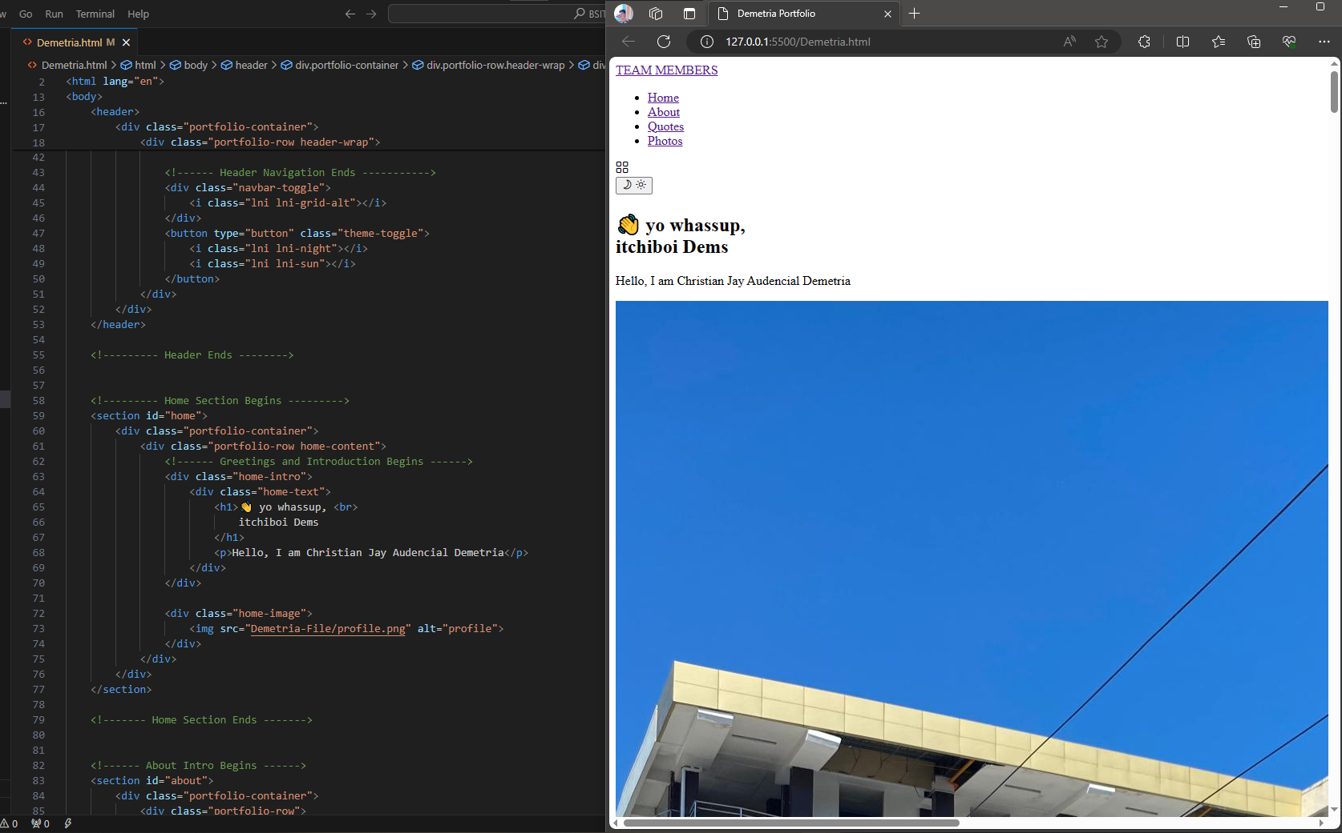 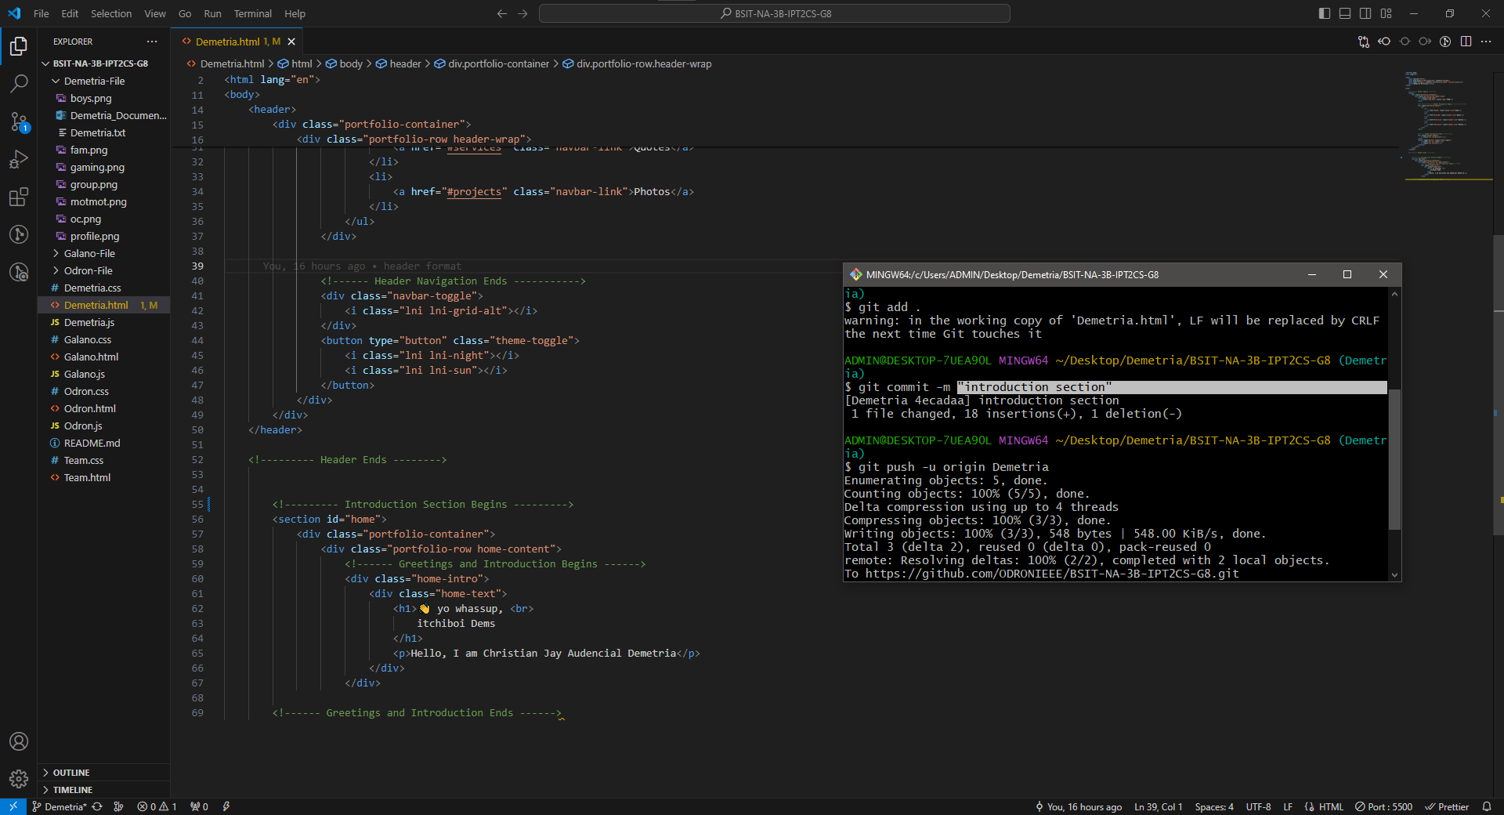

Introduction Section update for the homepage.

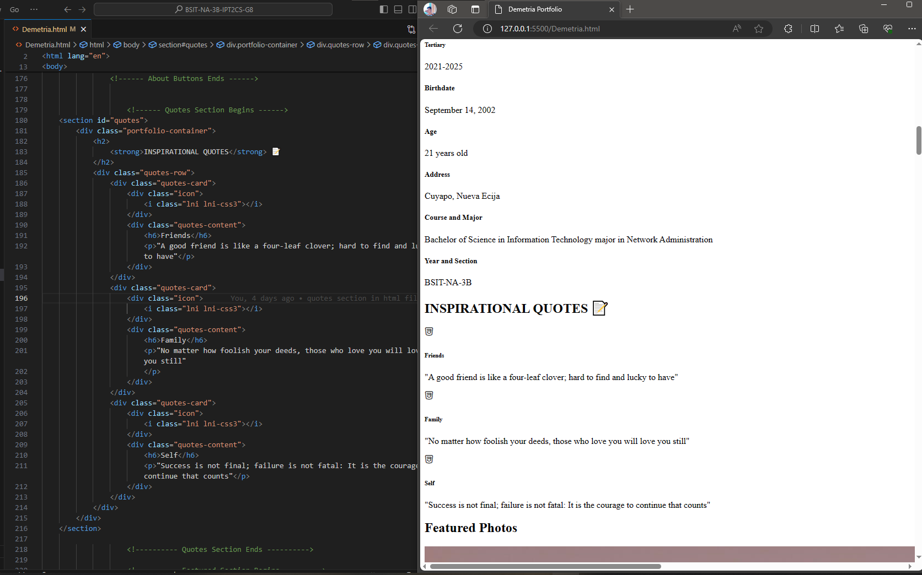

About and Quotes Section update. I added some inspirational quotes about Family, Friends, and for the Self.

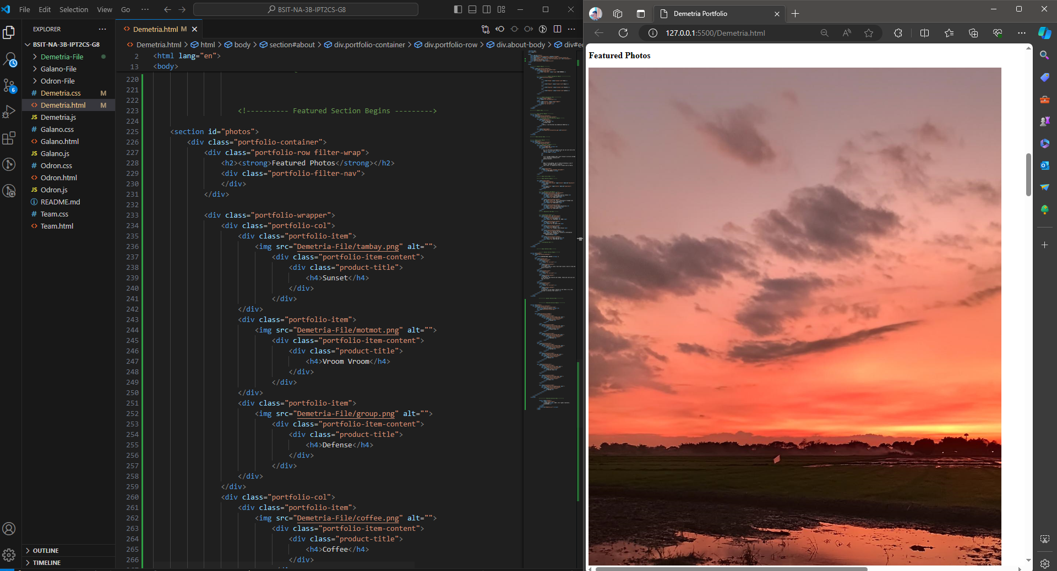

Featured Photos Section Added. All the necessary pictures needed for my portfolio were encoded in the html file.

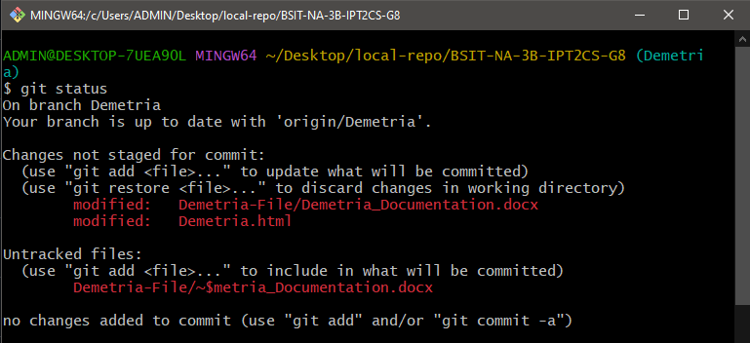

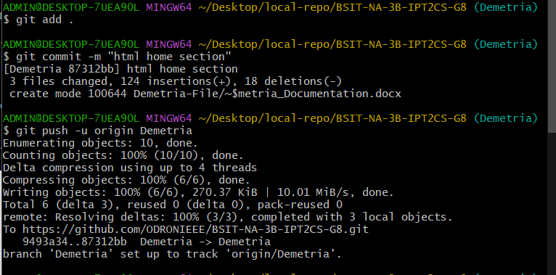

Adding and committing the files and then pushing them into my branch ‘Demetria’

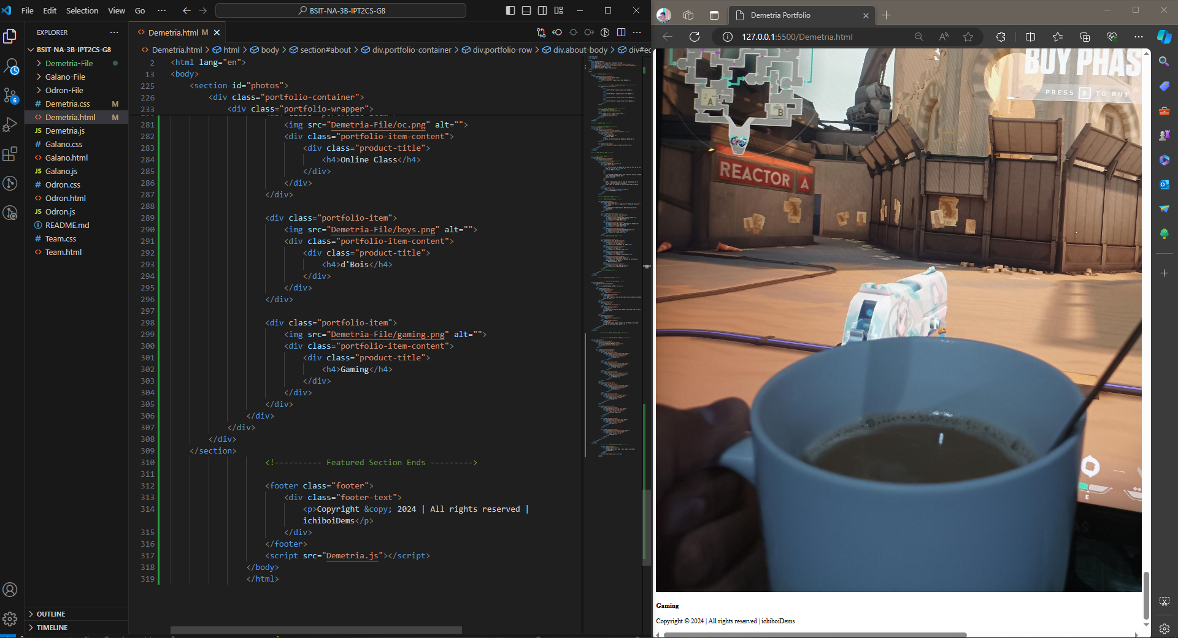

This draft is just the complete html file with no design or the CSS file.

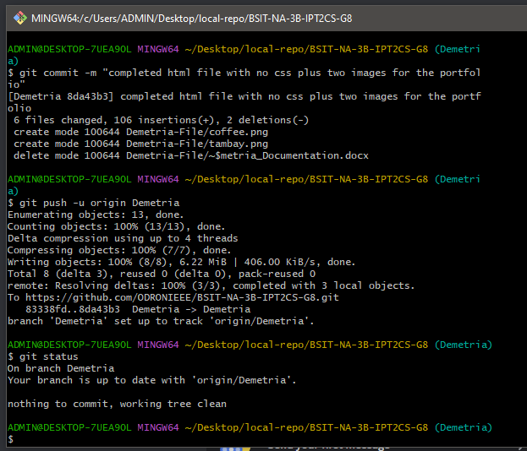

Pushing the completed files into my branch.

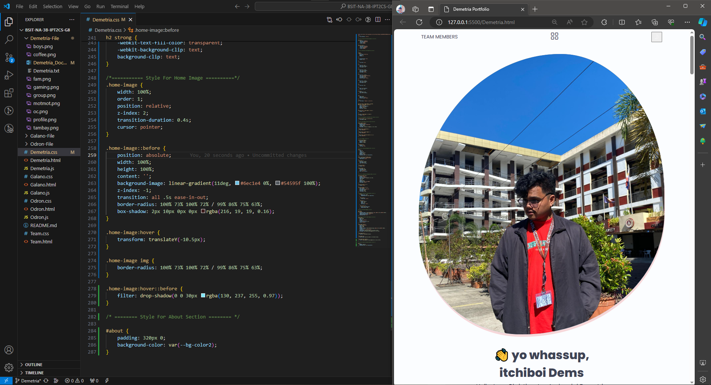

CSS Code updates up to the Home Section of the Portfolio. The profile picture and the fonts of the introduction message have been updated with some style.

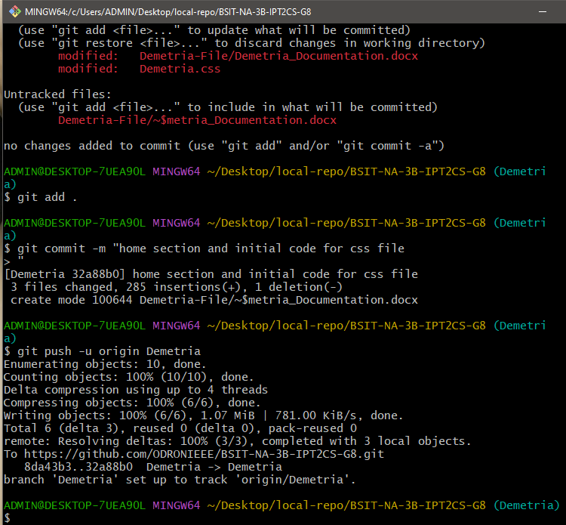

Adding, committing, and then pushing the updates into the Demetria branch.

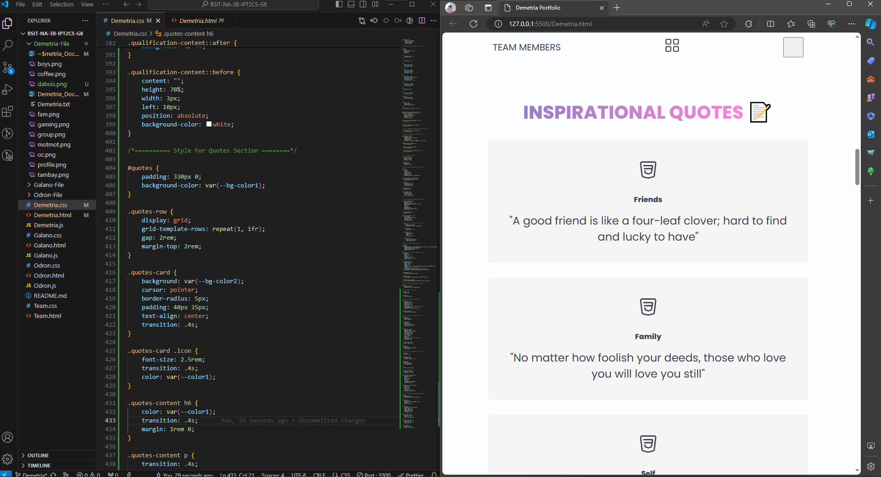

CSS code update on Quote Section and changes on some pictures for Featured Photos are made. I added some pictures for the Featured Photos Section for the alignment of the other pictures.

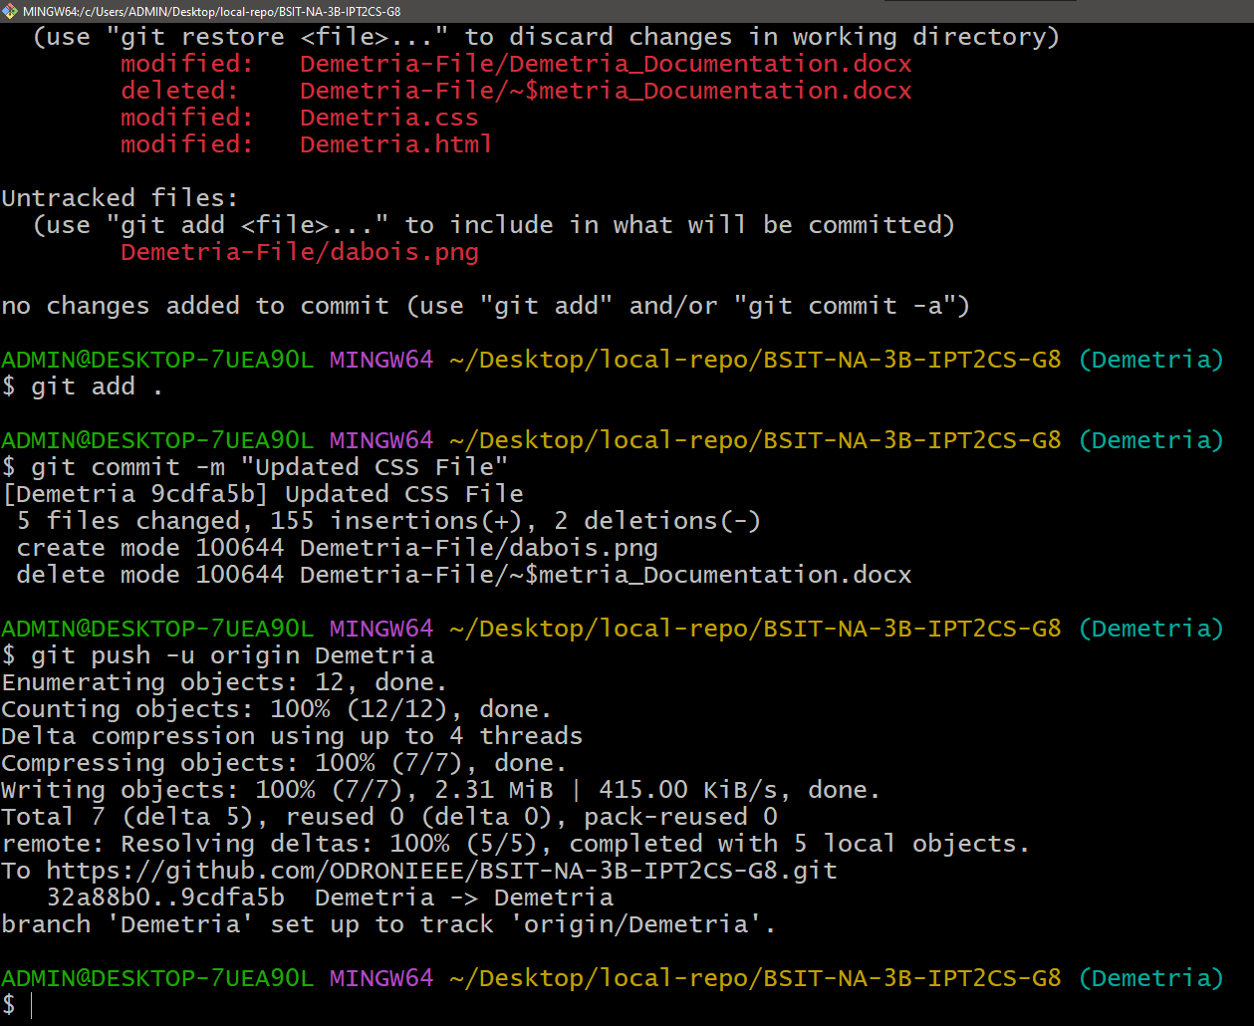

Adding, committing, and then pushing the updates into the Demetria branch.

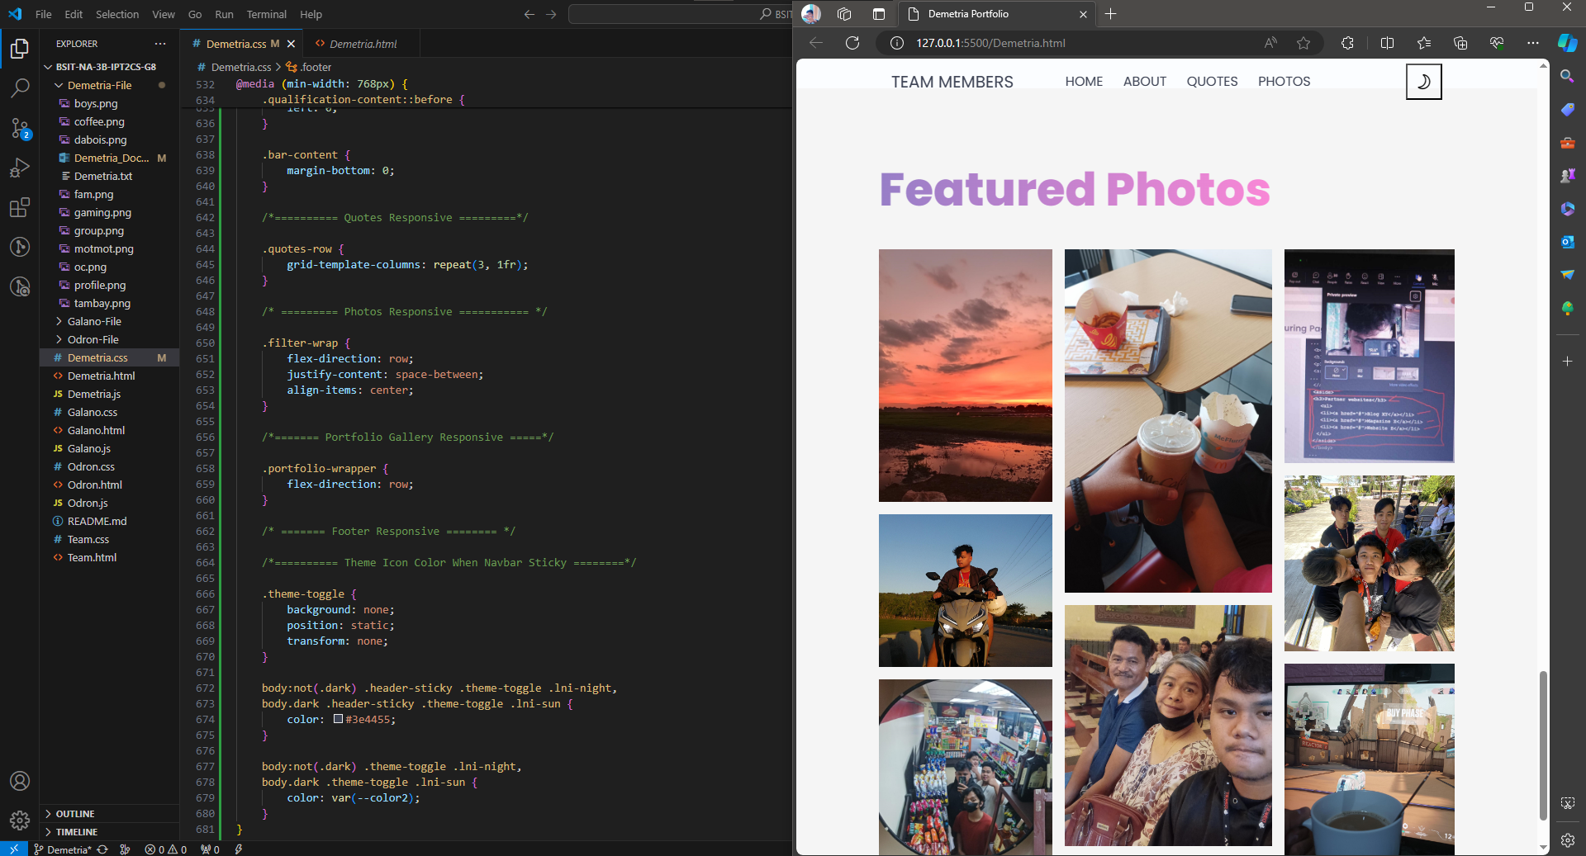

Revision of CSS File without JavaScript. In this version, I organized the structure of the website with the design, color of the background, and the fonts used. With this, the website looks more pleasing to the eyes.

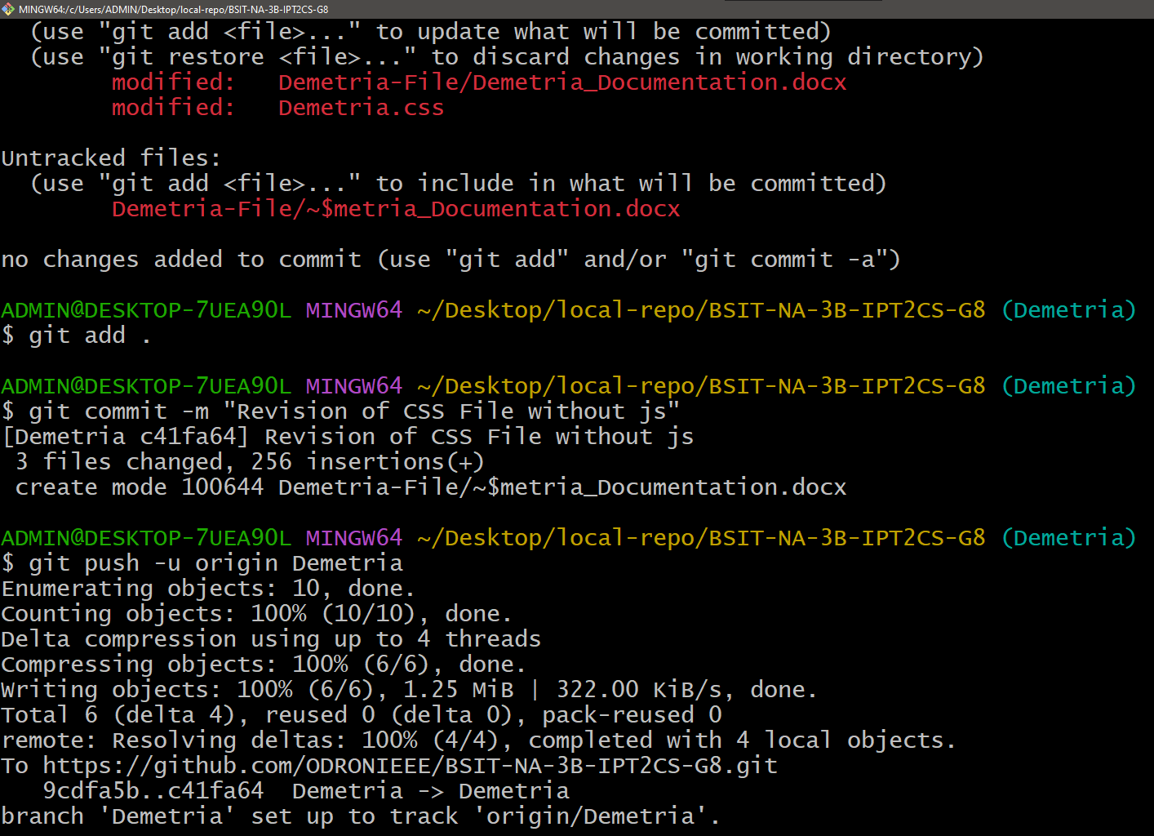

Adding, committing, and then pushing the updates into the Demetria branch.

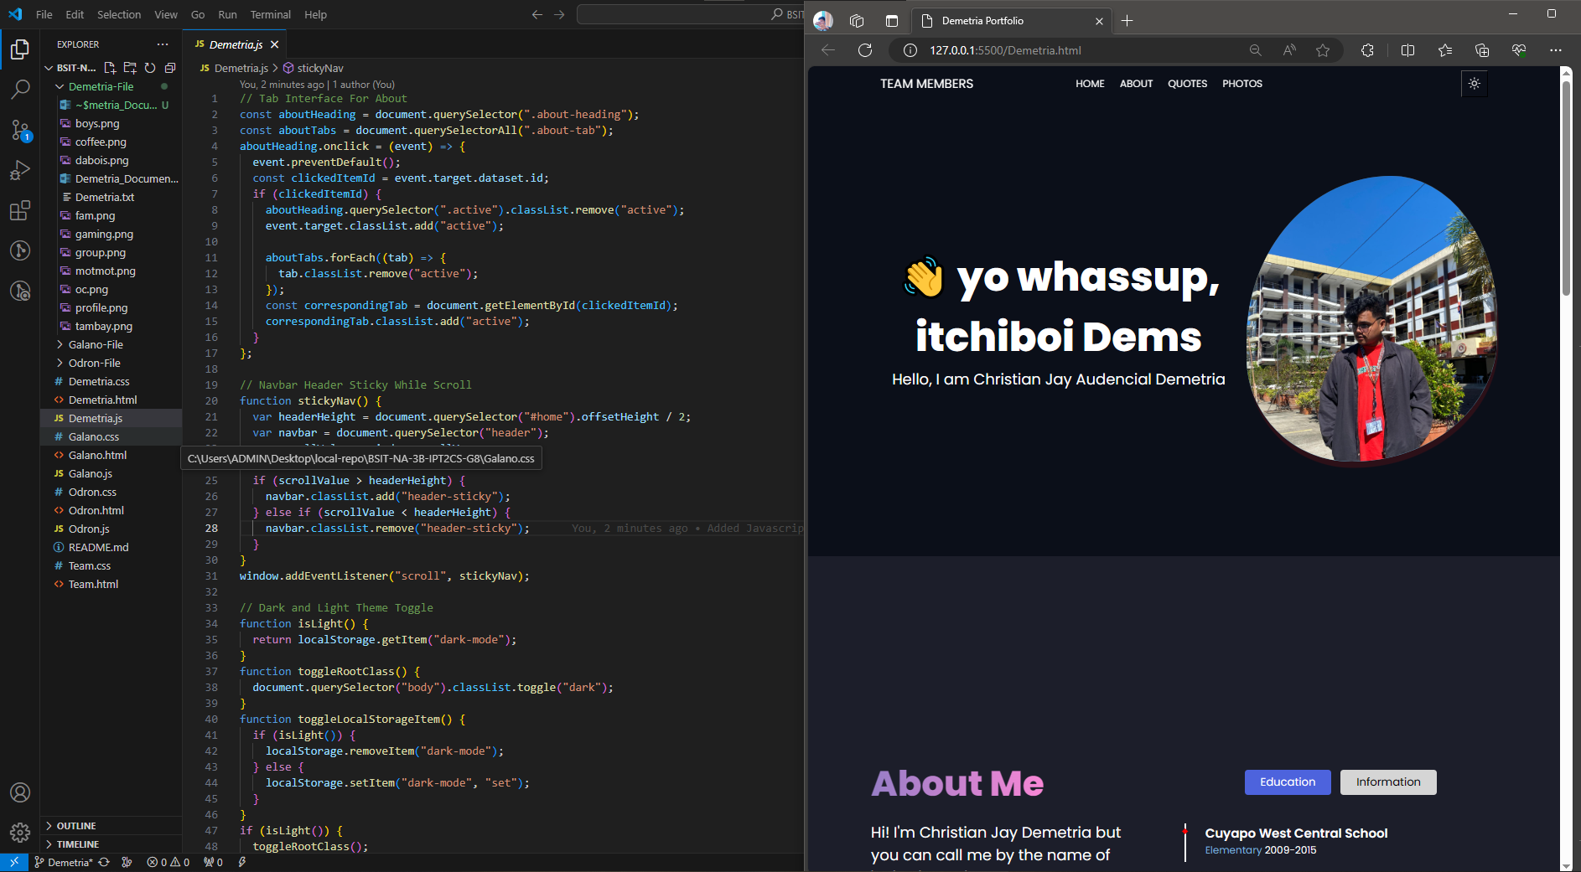

Adding JavaScript for the structure of my website for the buttons like the Dark and Light mode to function.

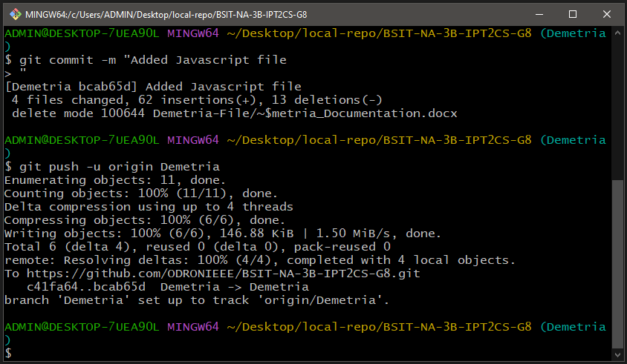

Adding, committing, and then pushing the updates into the Demetria branch.

When a file was created or modified on the local-repo folder, the state of the files is untracked and by using the **git add .** command, all the modified/created files will be tracked. Lastly by using the **git commit -m “message”**, you take snapshot of the current version of the file. In the commit command, you can leave a message for other collaborators to comprehend what is the update of your work. By using the command **git push -u origin Demetria**, all the tracked files in the local repo were added to my branch in Git Hub.

**FINAL VERSION OF MY PORTFOLIO (PREVIEW)**

**DEFAULT MODE**

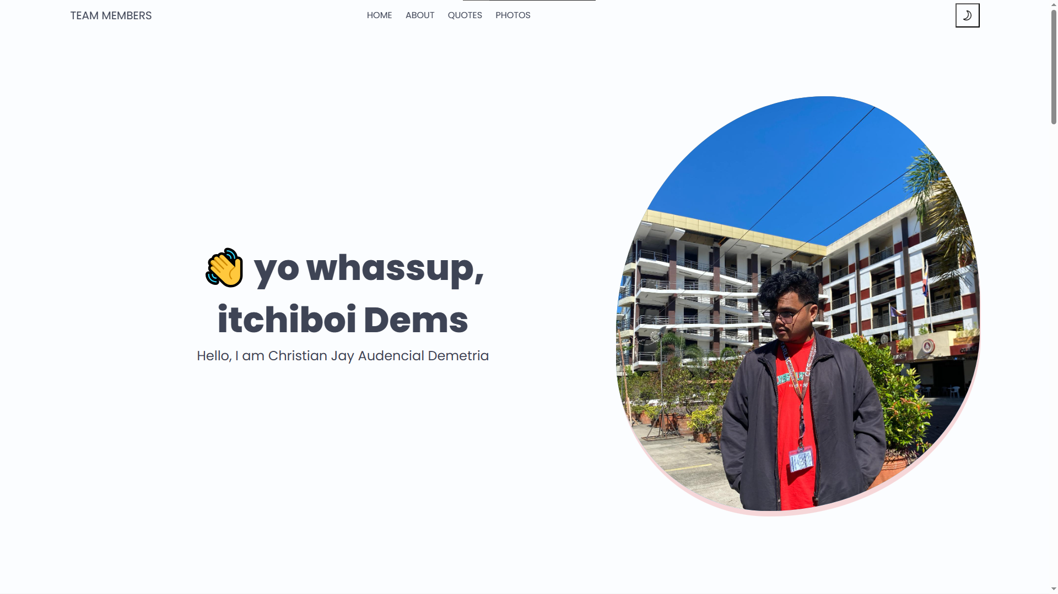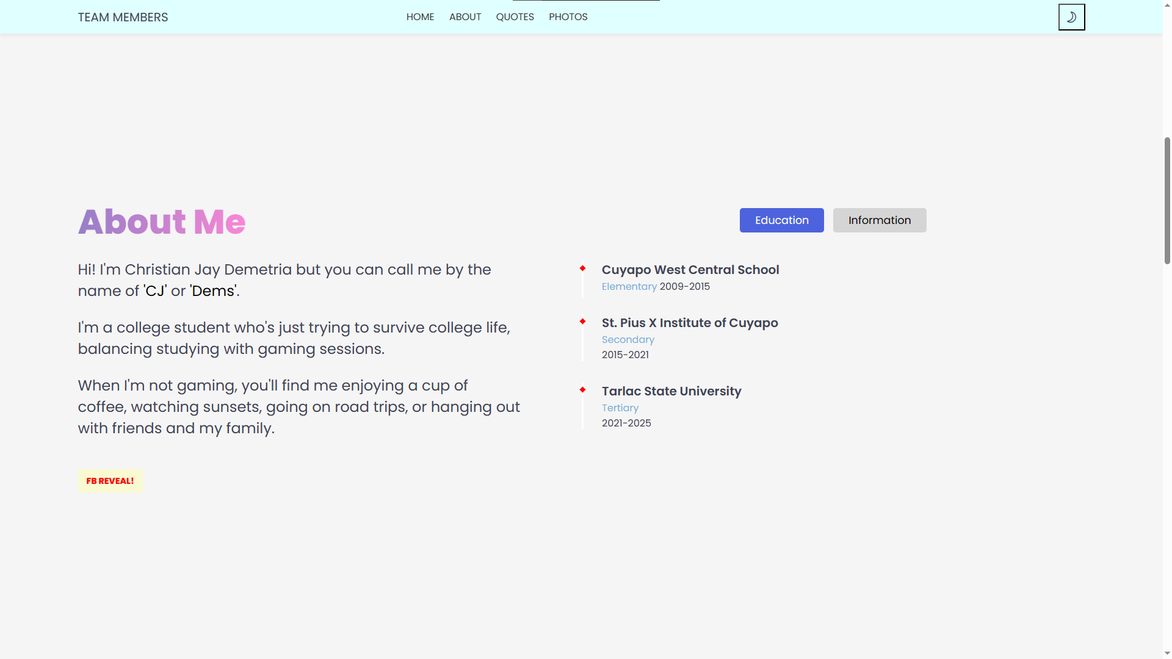

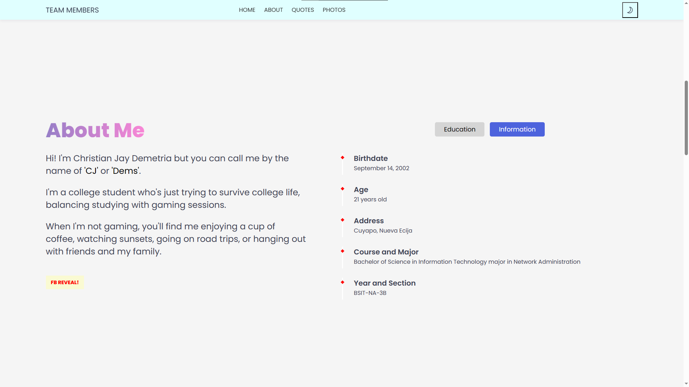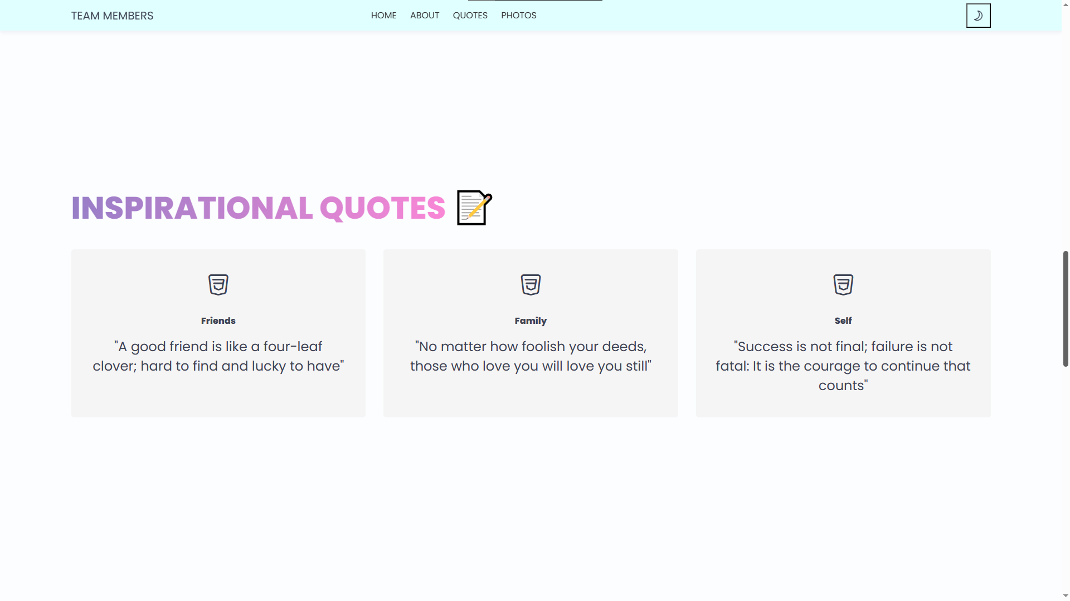

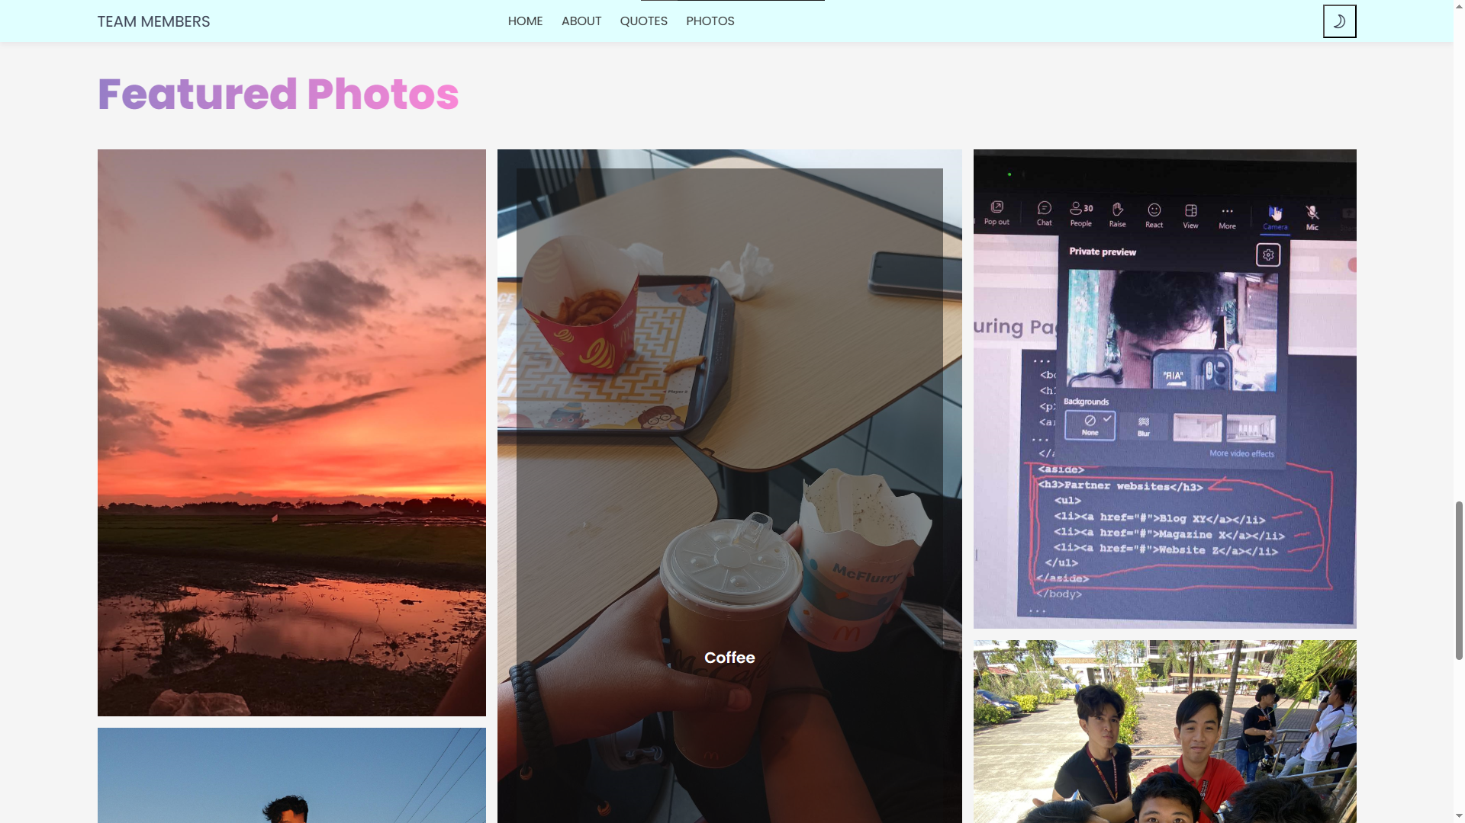

**DARK MODE**

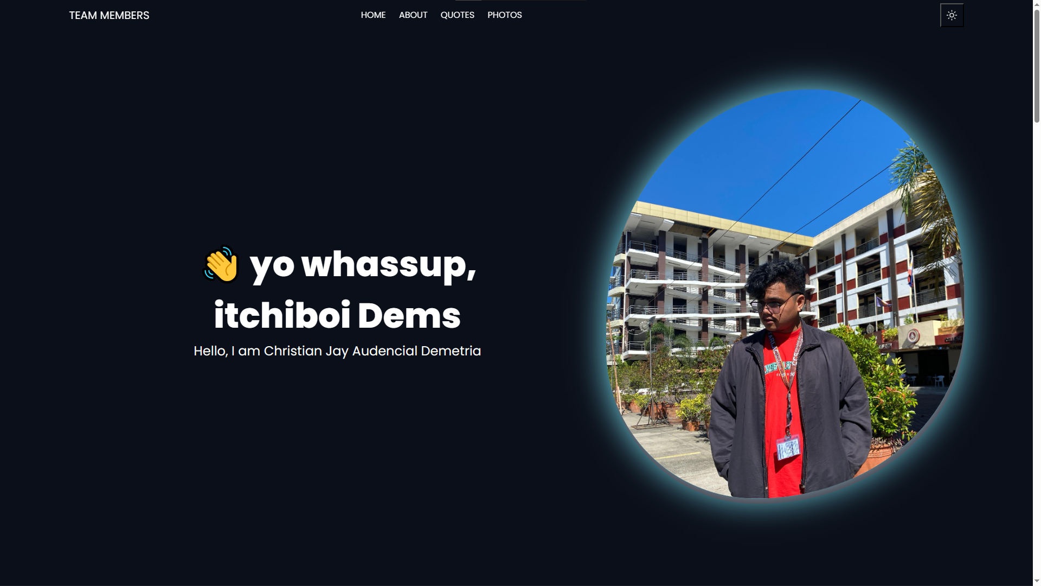 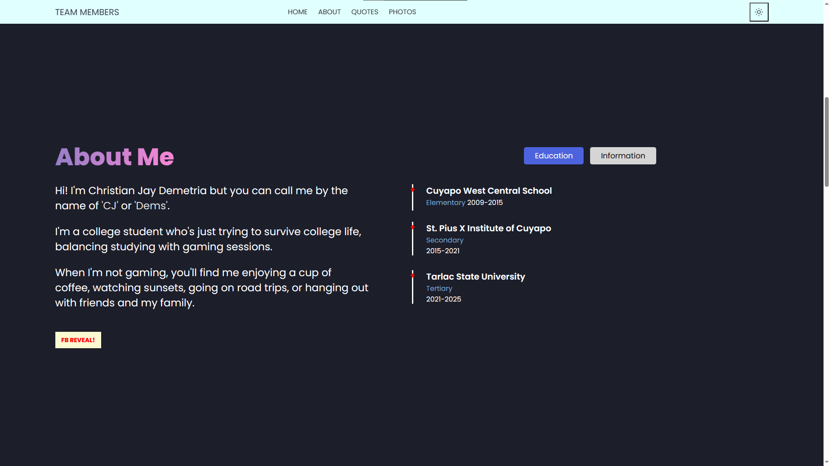

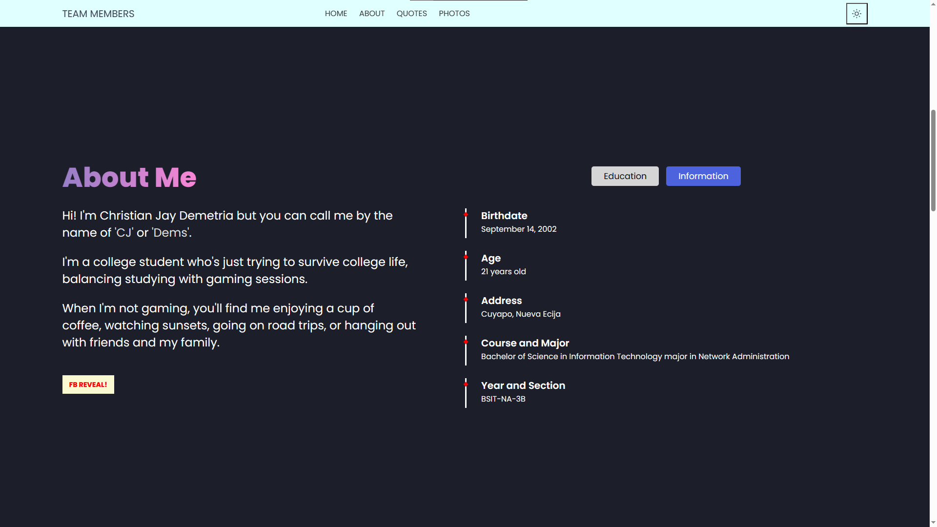 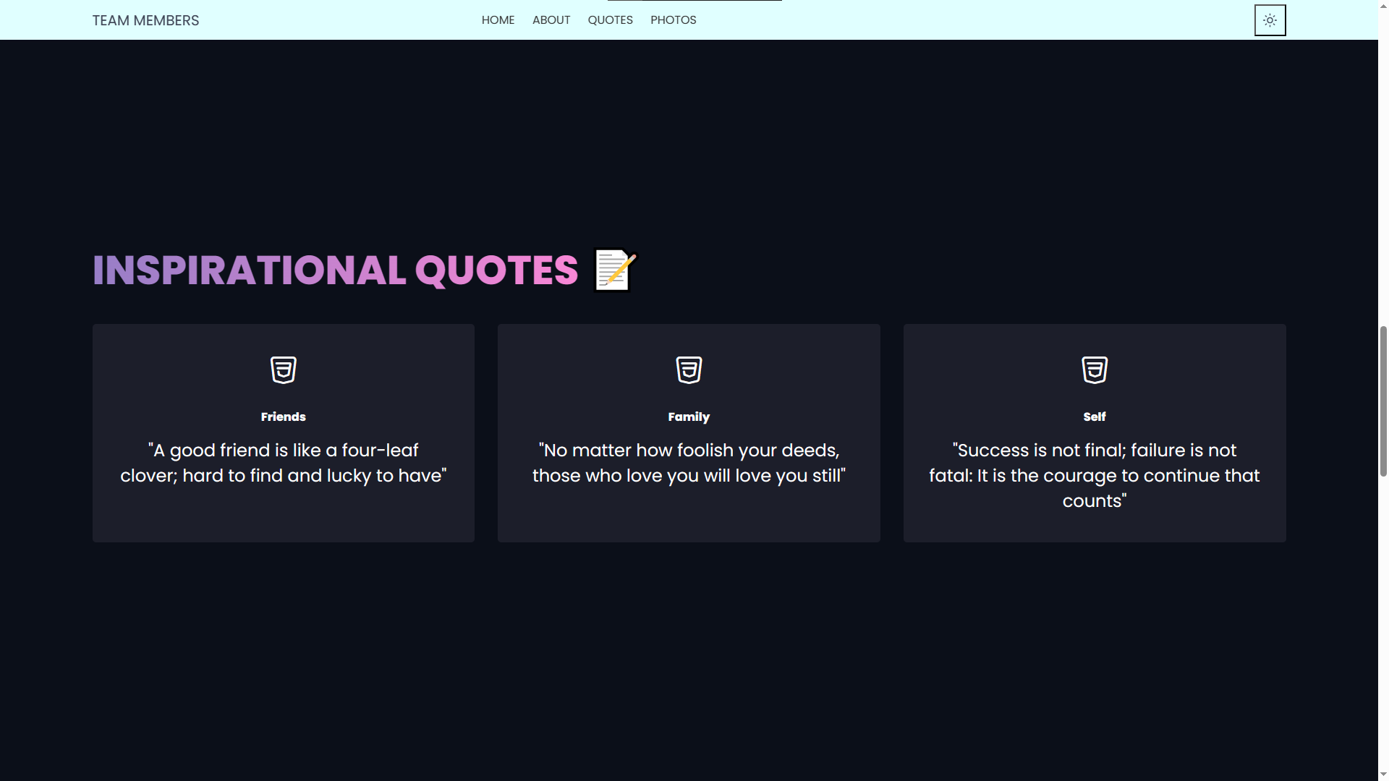

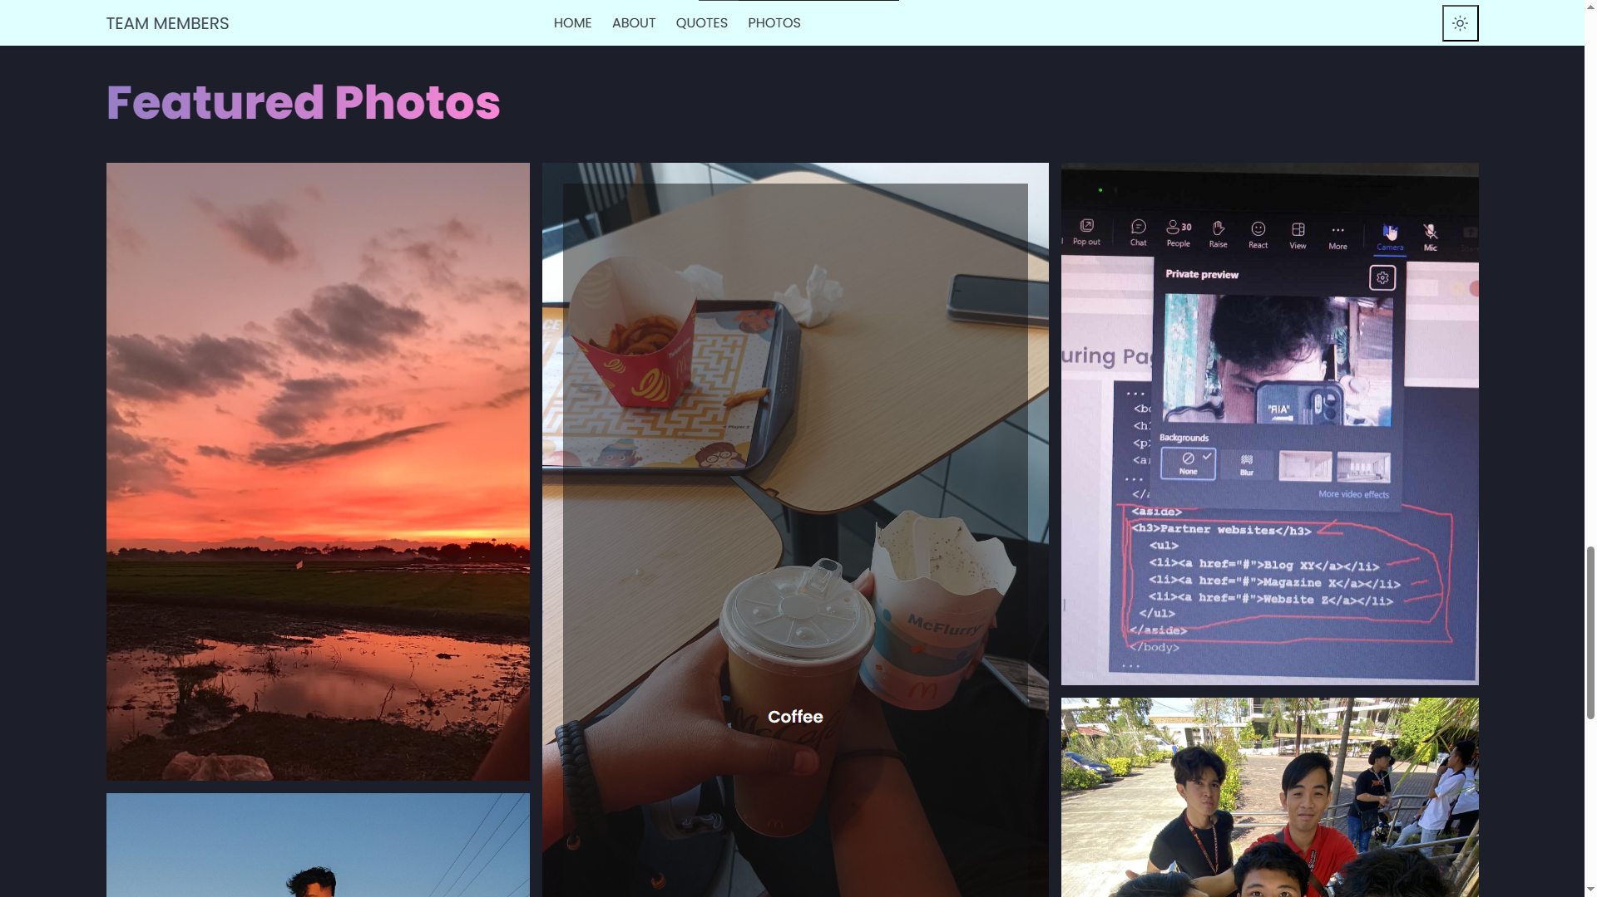

**ISSUES AND MILESTONE**

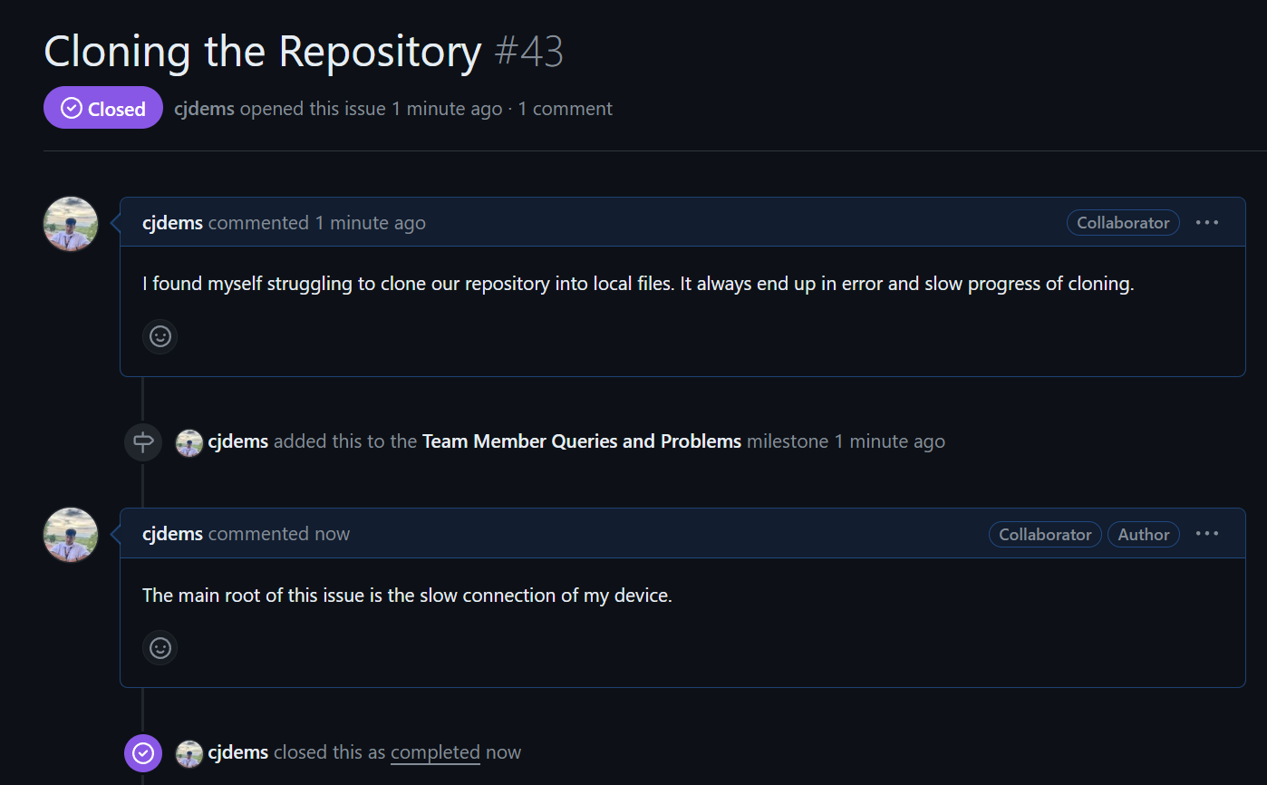

Cloning issue resolved upon checking the connection of the device into the network.

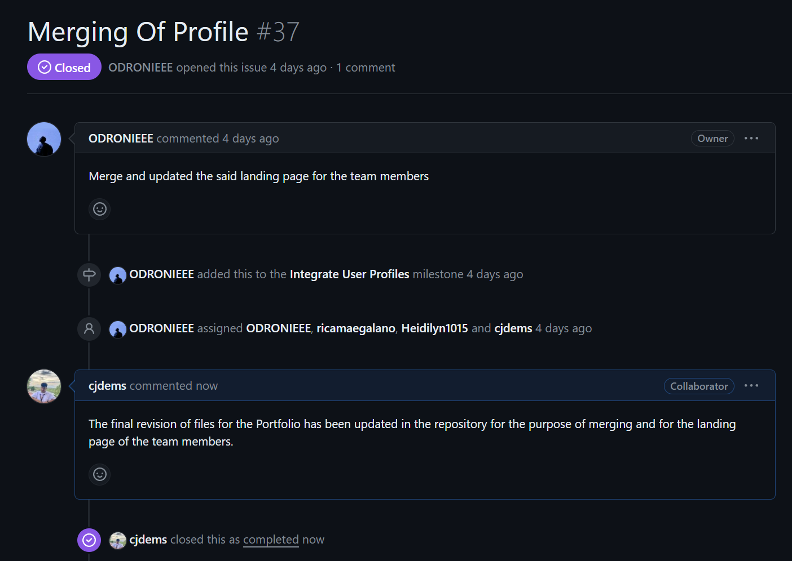 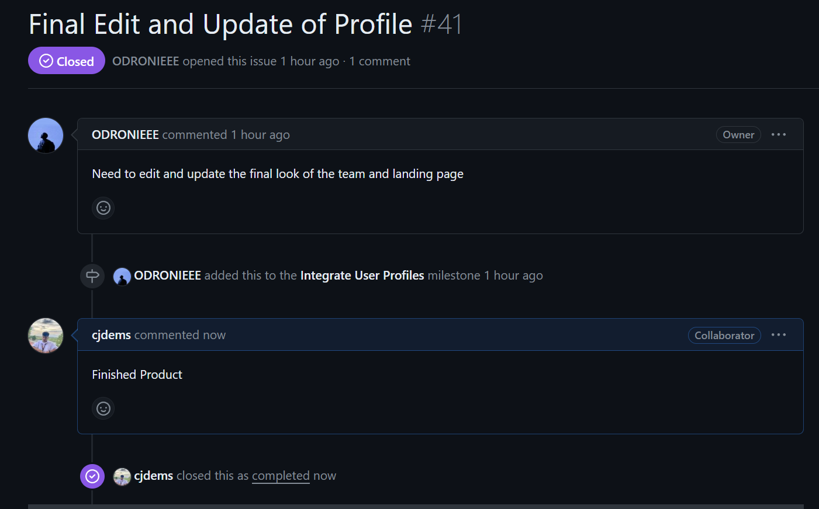

The completed version of portfolio has been pushed inside the repository.

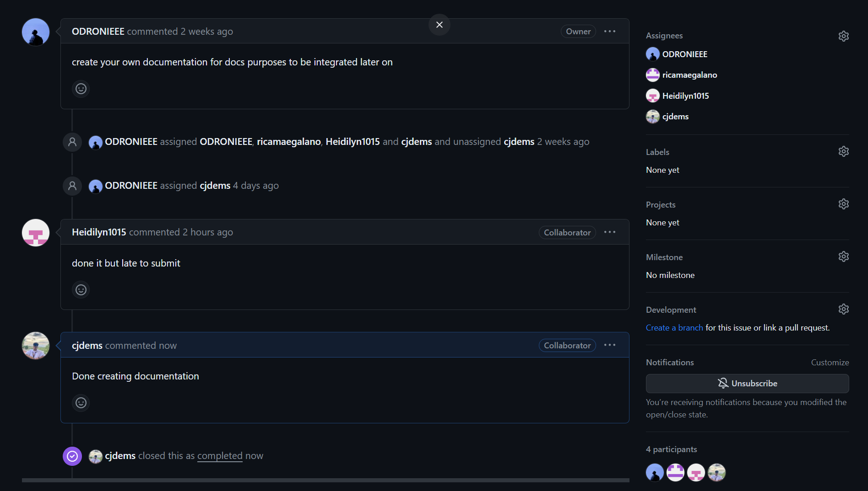

Proper documentation on how we utilized git and Git Hub.

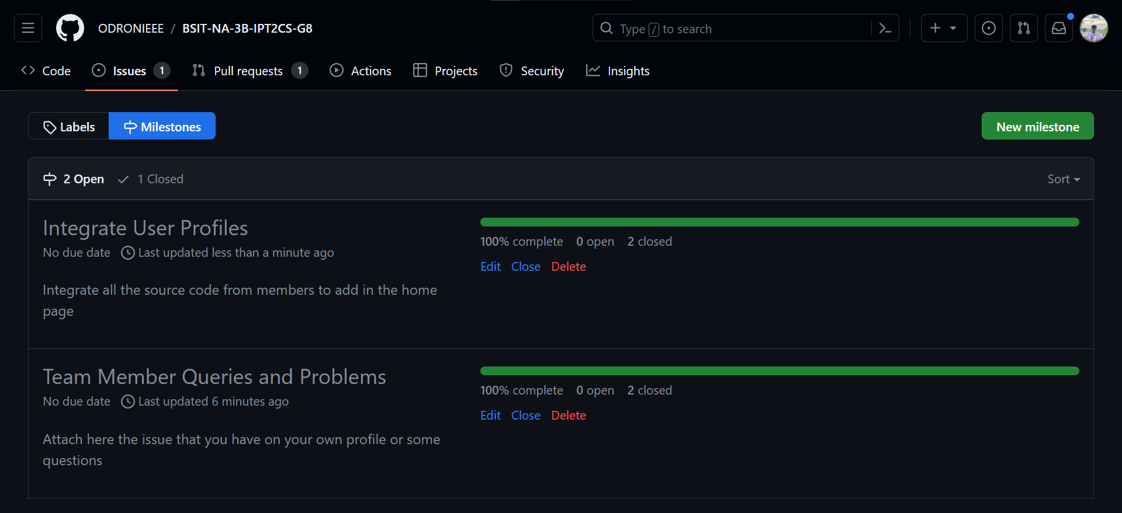

In this part, the 2 milestones shown in this picture have been completed.

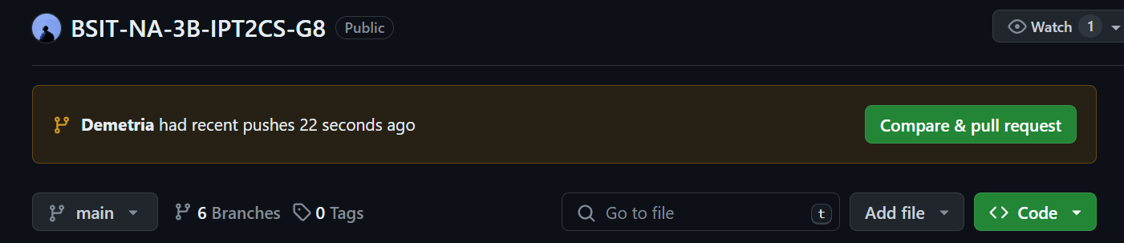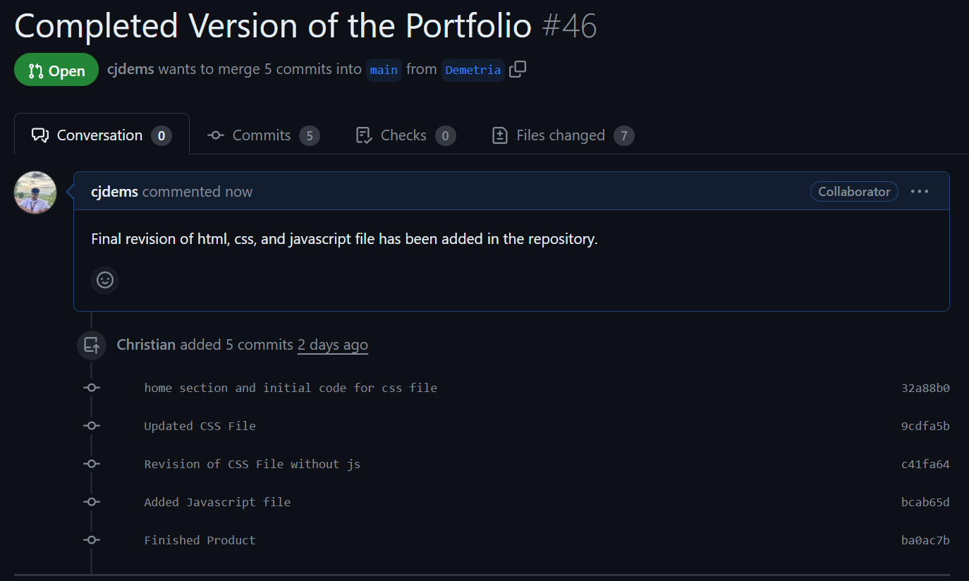

Upon finishing the said requirements, the use of pull request in Git Hub proposes the possible merging of completed files to the default branch of the repository (Final Merge). Our leader will check first if there is no conflict on the branch when merging with the main branch.